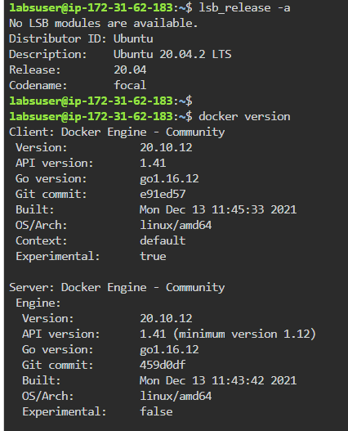

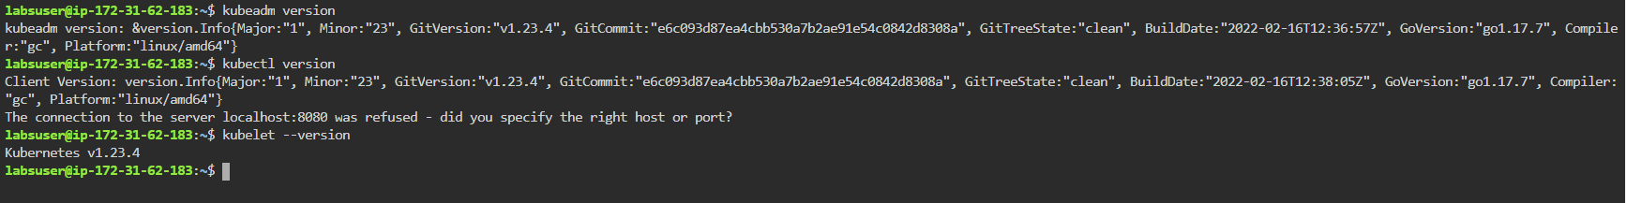

**Setting up the master node and configuring the cluster:**

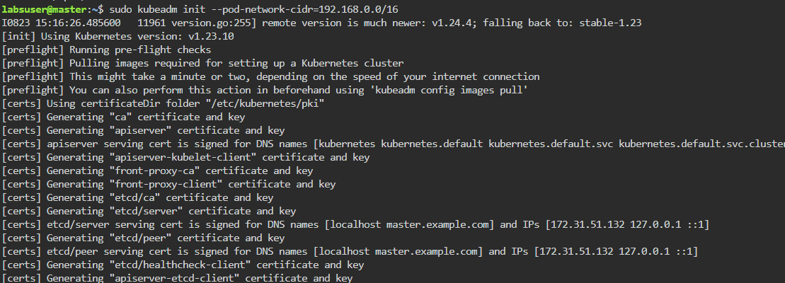

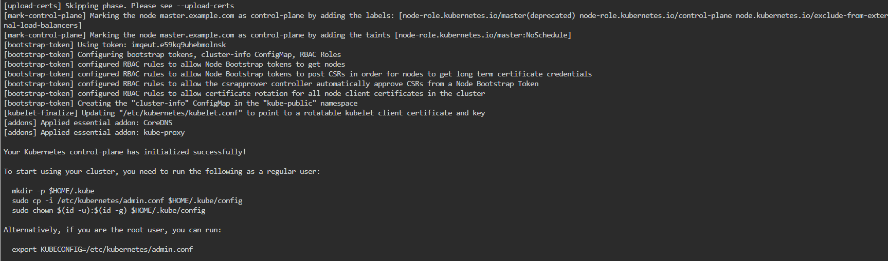

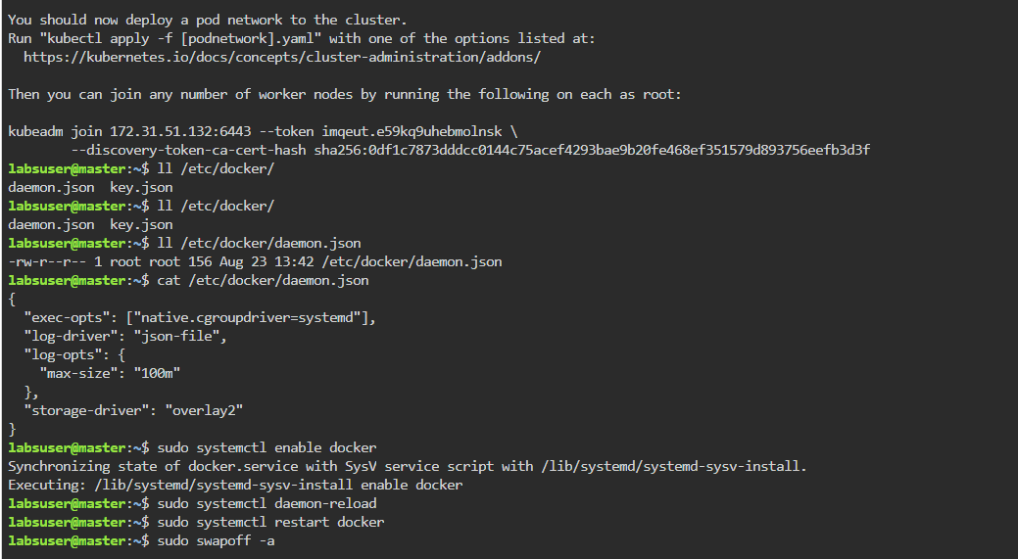

Master node to allow non-root users to access use kubeadm:

Run the following command on Master node for joining the worker nodes to the cluster

**sudo kubeadm token create --print-join-command**



**Joining the worker nodes to the cluster**

**Joining worker node-2**

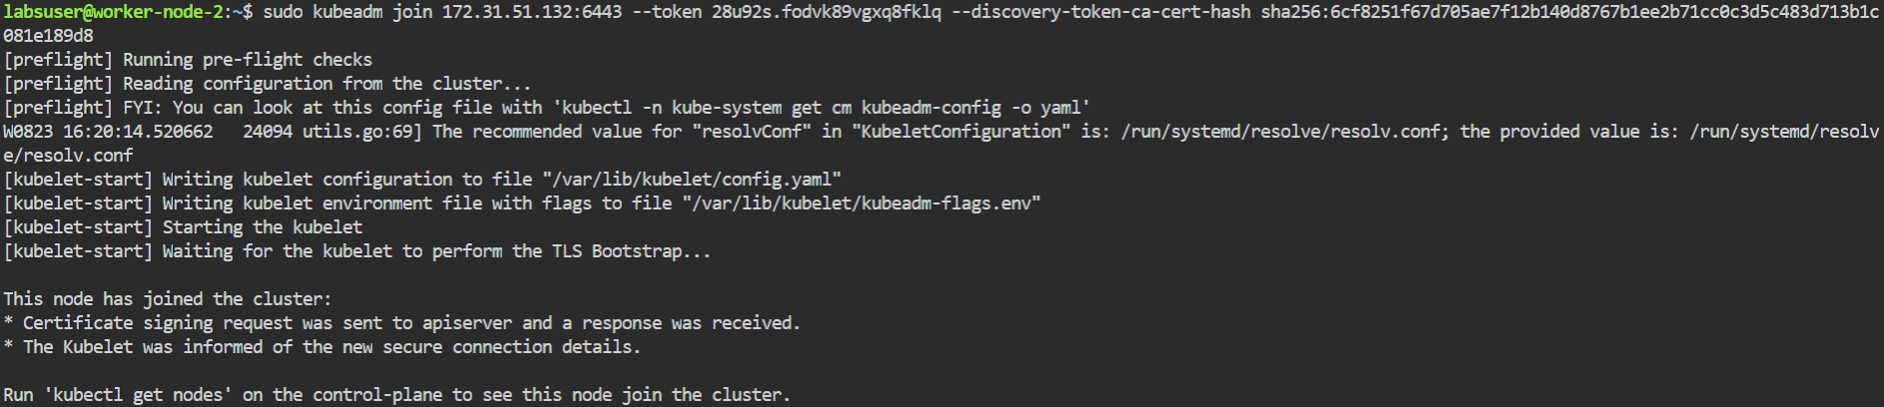

**Joining worker node-1**

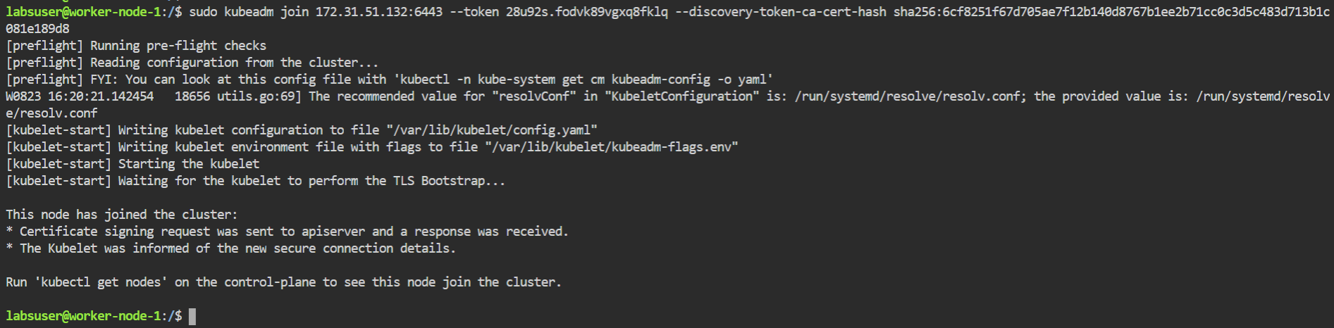

**Verifying the nodes in the cluster**

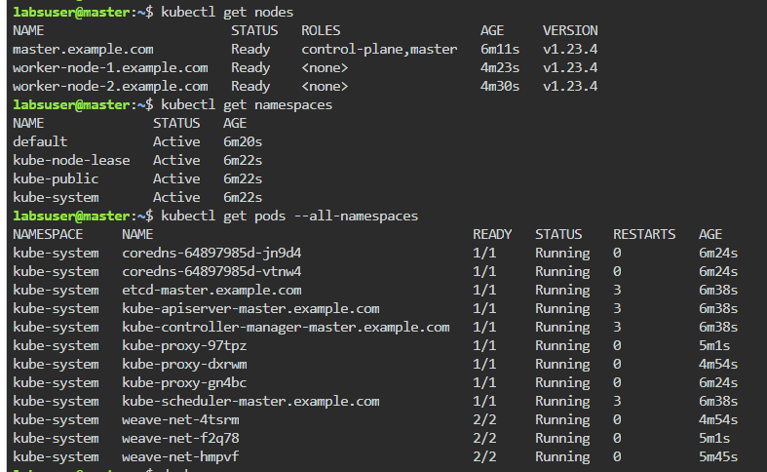

Deploying the Dash Board:

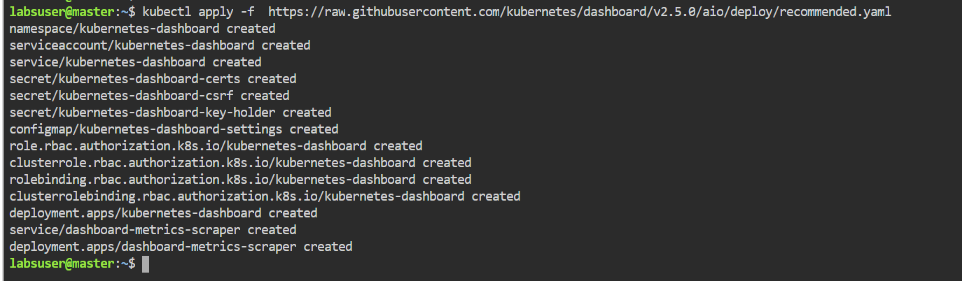

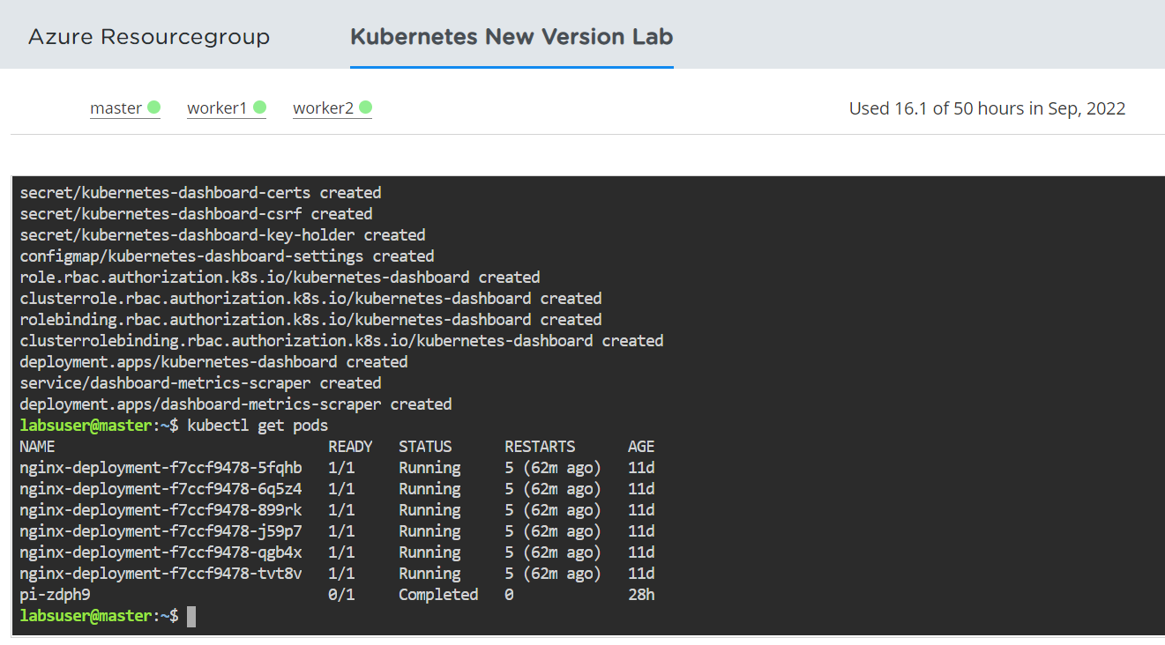

**Verifying the Pods, Services, and Deployments**

To verify if the Pods, Services, and Deployments are created or not, use the following commands:

**kubectl get pods -n kubernetes-dashboard -o wide**



**kubectl get deployment -n kubernetes-dashboard -o wide**



**kubectl get svc -n kubernetes-dashboard -o wide**

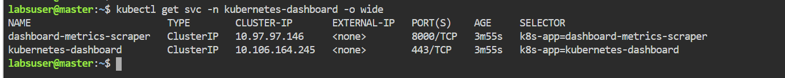

**Editing the Service type of the dashboard**

To access the Service outside the cluster, edit the Service type **ClusterIP** to **NodePort**:

**kubectl edit svc -n kubernetes-dashboard kubernetes-dashboard**

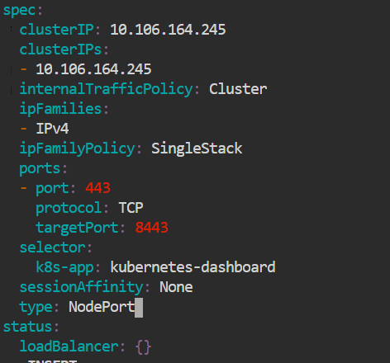

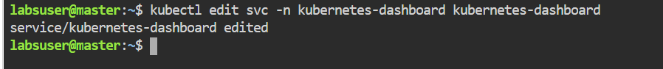

**Verifying the Service type of the dashboard**

To verify if the Service type is changed to **Nodeport**, use the following command:

**kubectl get svc -n kubernetes-dashboard -o wide**

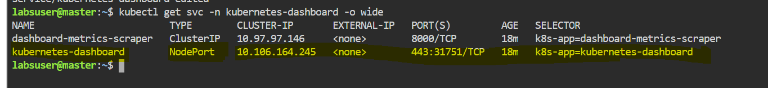

**Checking where the Pod is running**

To check where the Pod is running, use the following command:

**kubectl get pods -n kubernetes-dashboard -o wide**



**kubectl get svc -n kubernetes-dashboard -o wide**



**kubectl get nodes -o wide**



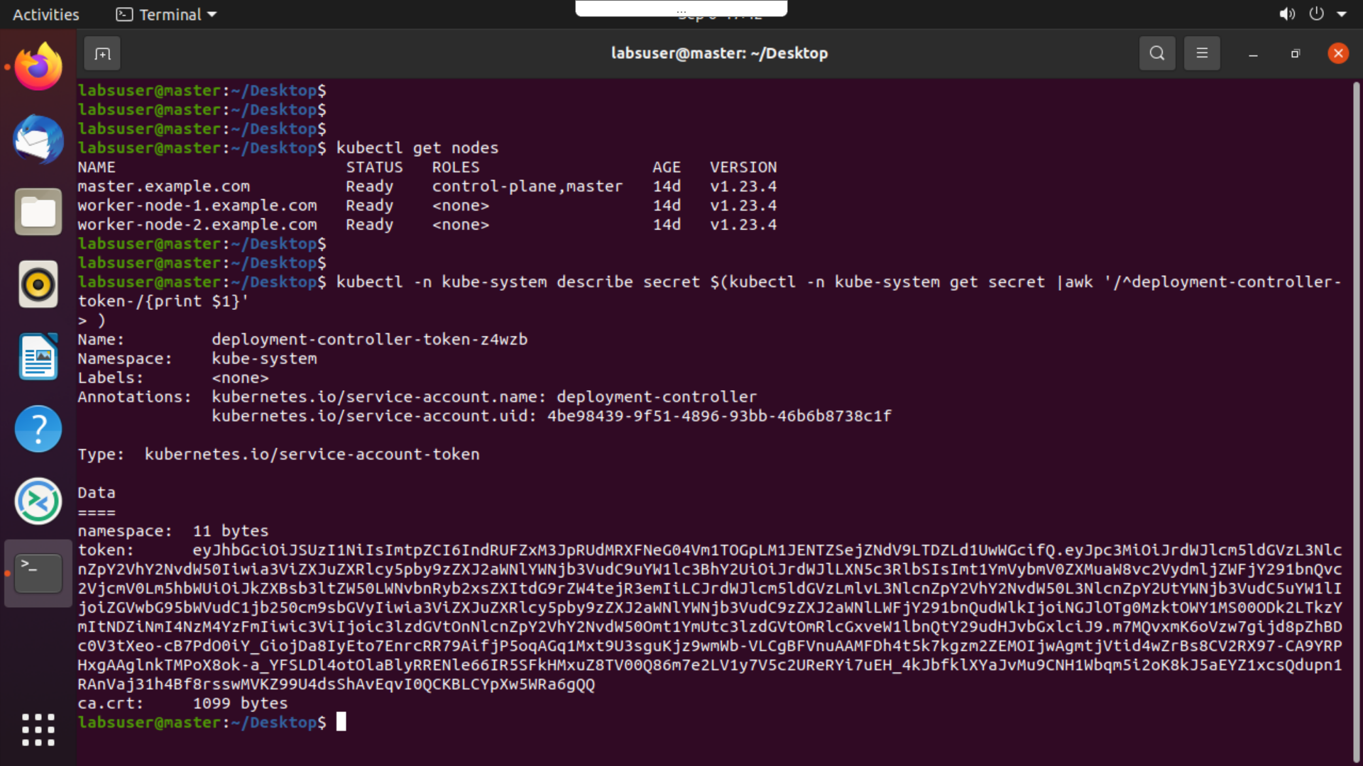

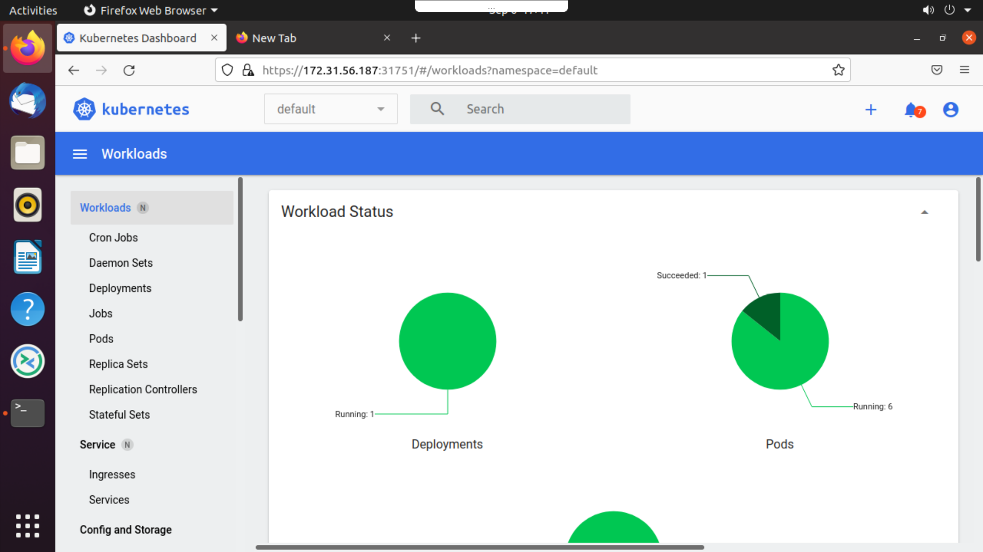

**Adding, deleting, and verifying cluster roles**

To find the resources available in the **kubernetes-dashboard**

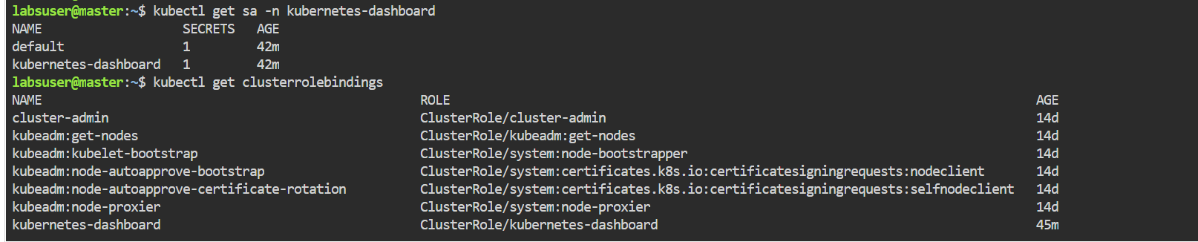 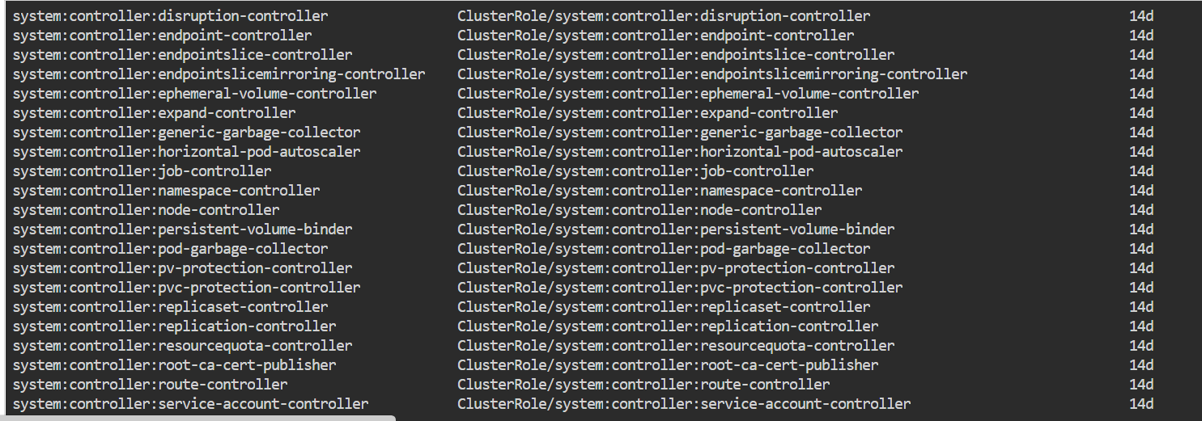

To assign a new cluster role, delete the existing one if available.

**kubectl delete clusterrolebindings kubernetes-dashboard**

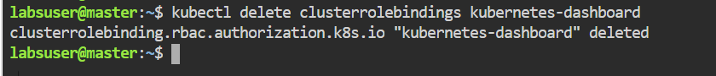

Create a new cluster role and set the **kubernetes-dashboard** to admin.



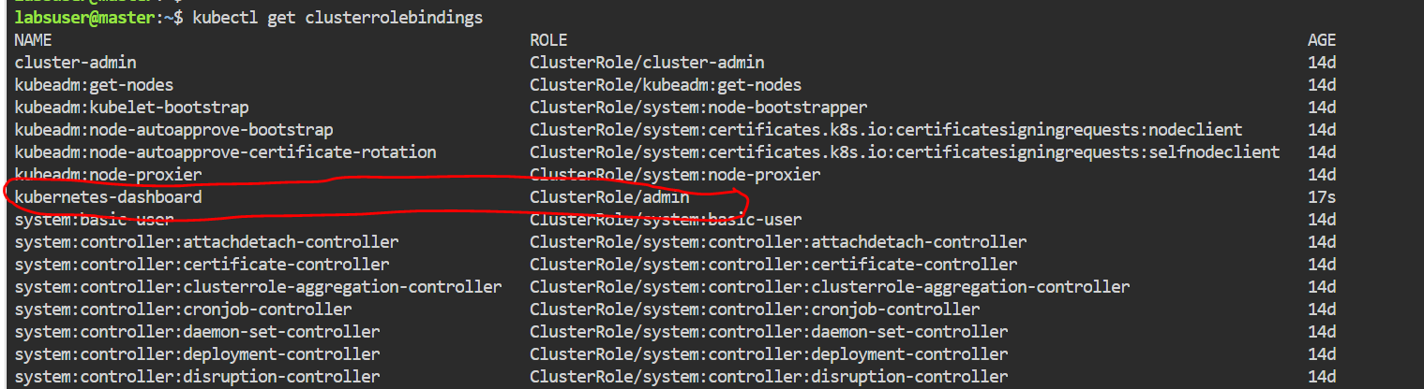

Create service account “sandry” and assign admin role to it.

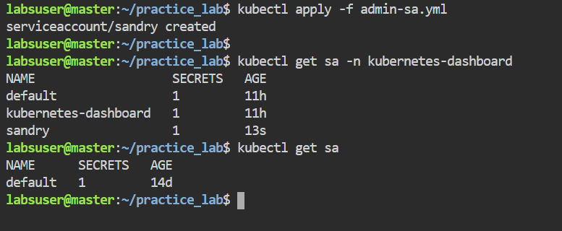

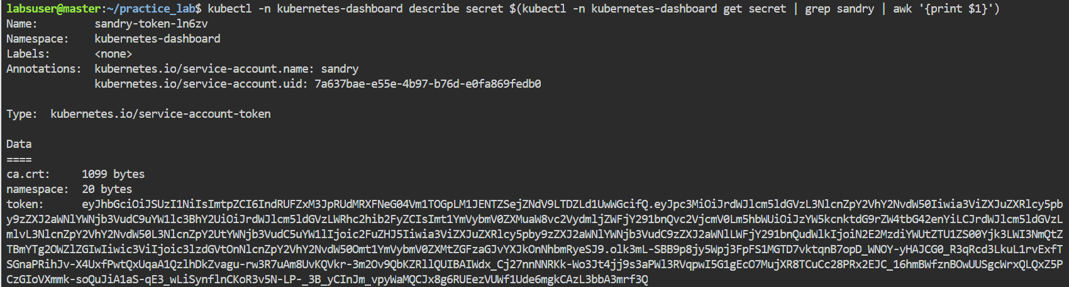

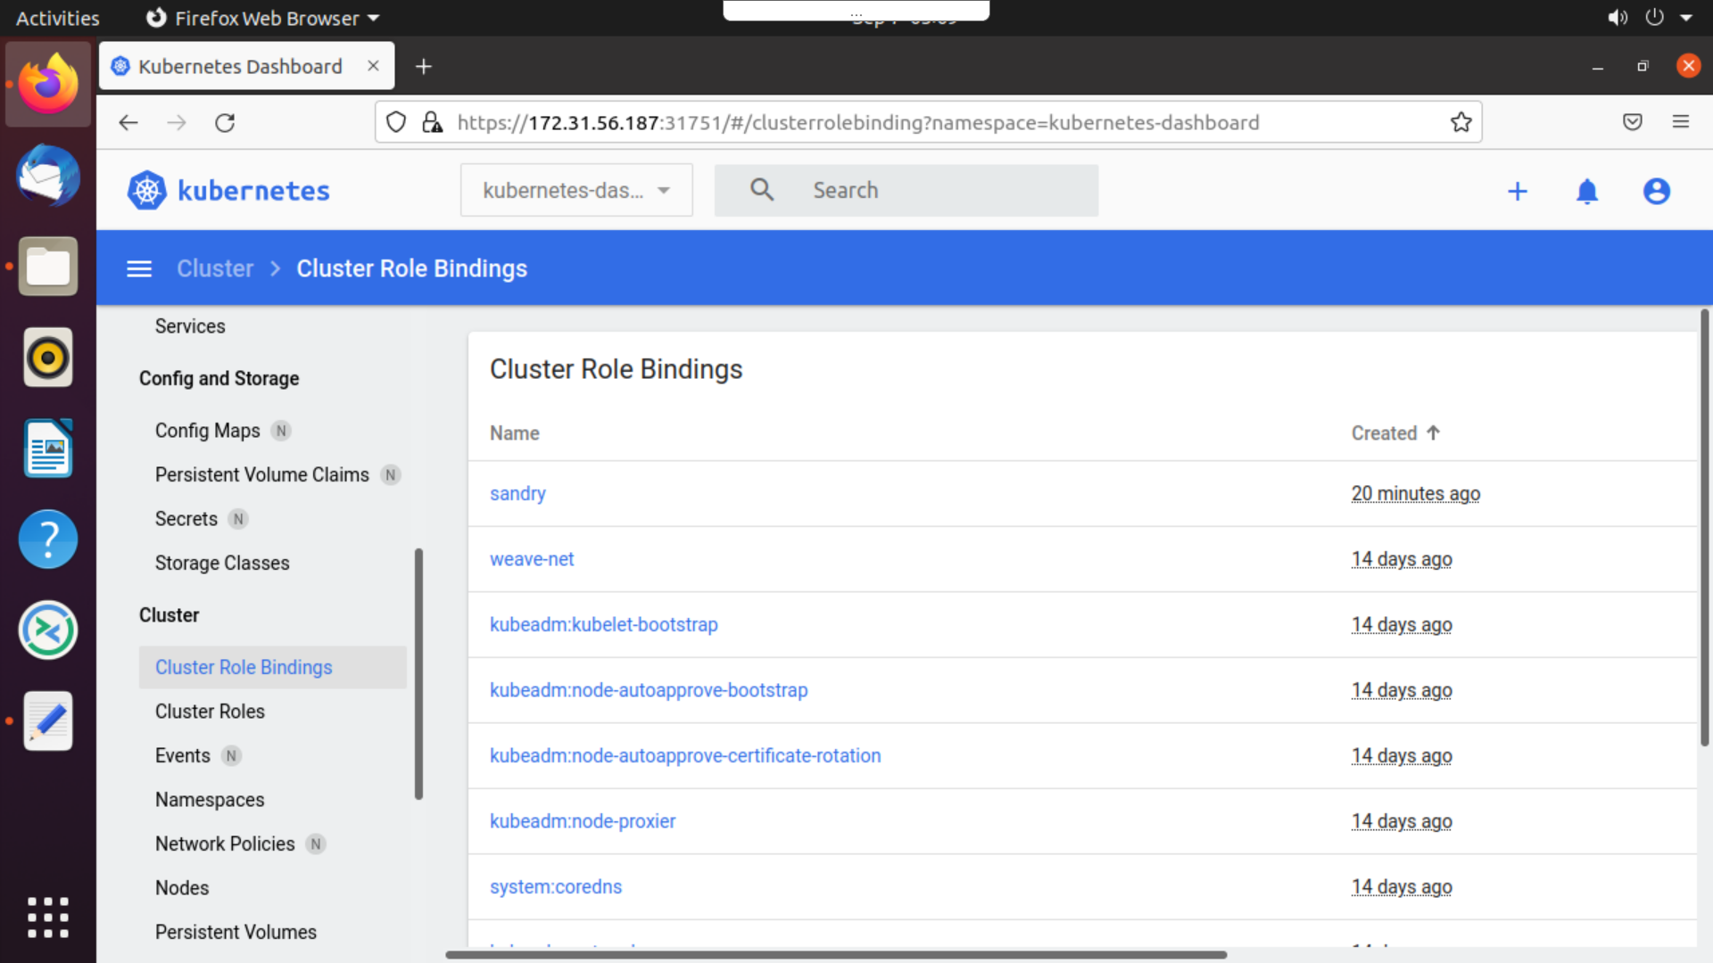

Configuring NFS server:

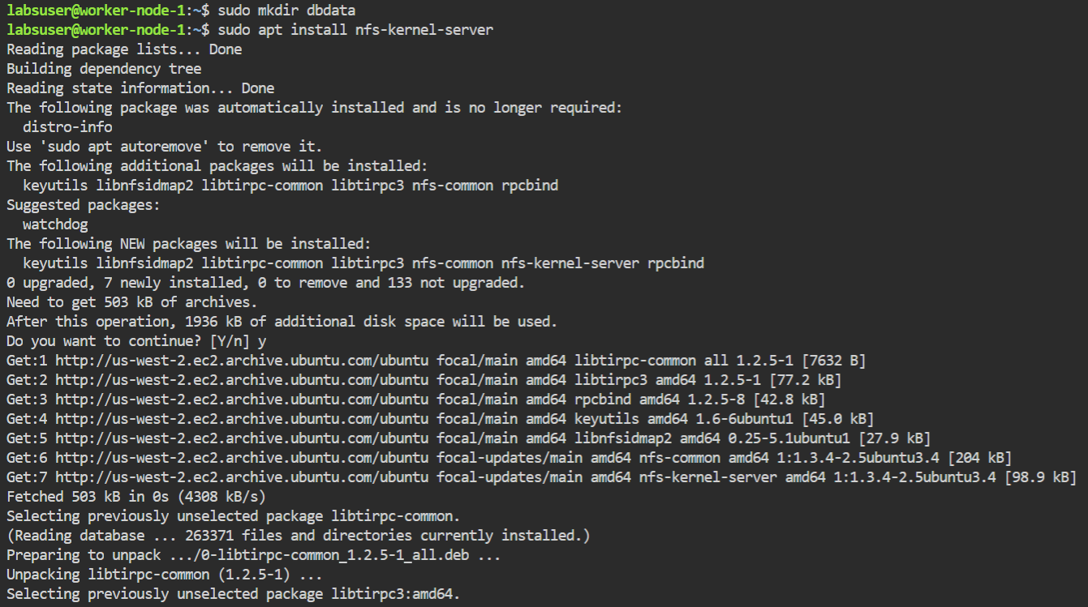

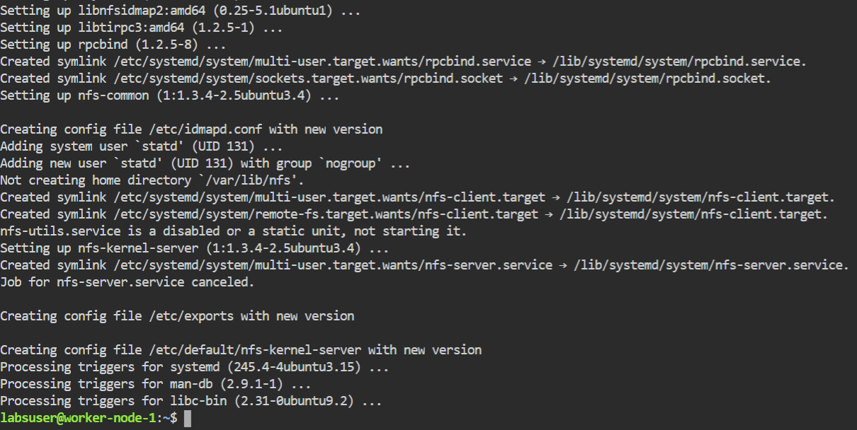

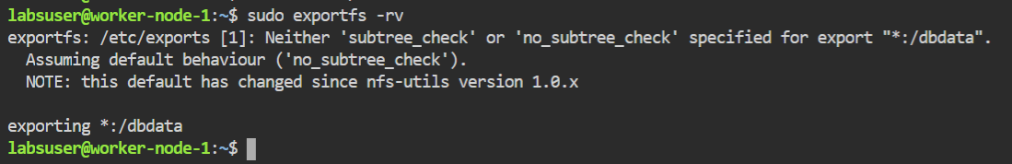

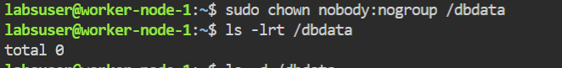

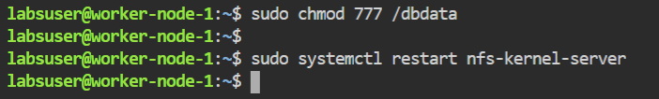

**Configuring the NFS common on client machines**

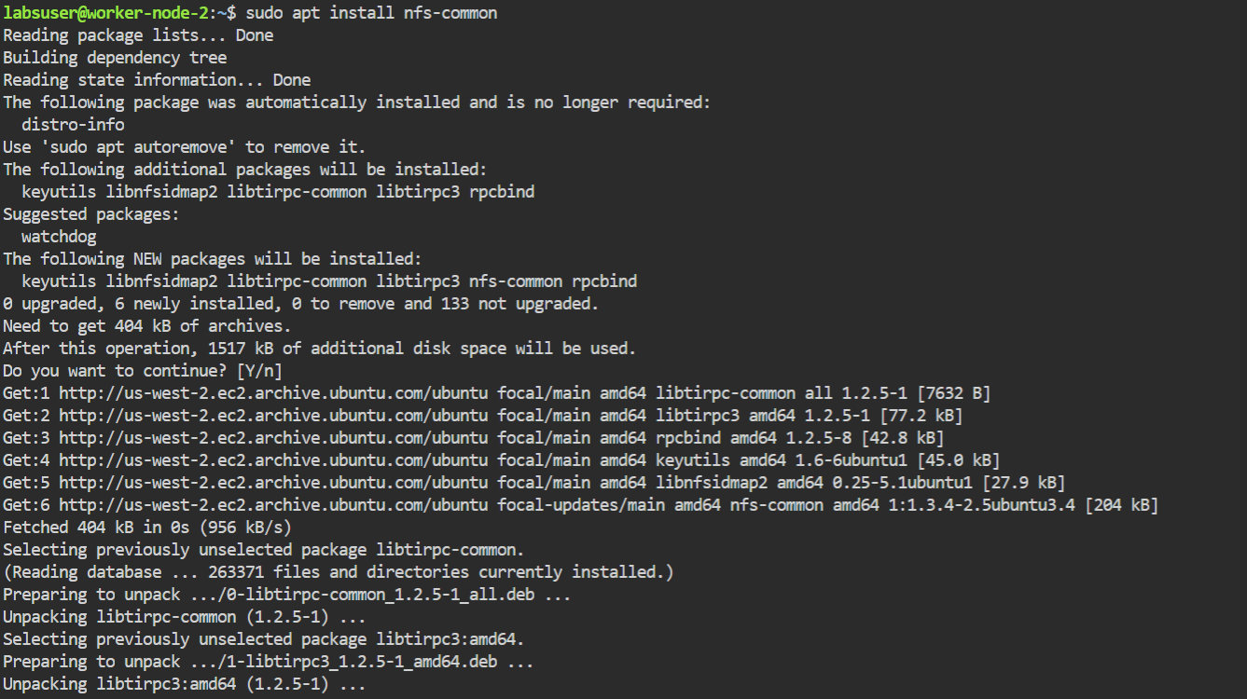

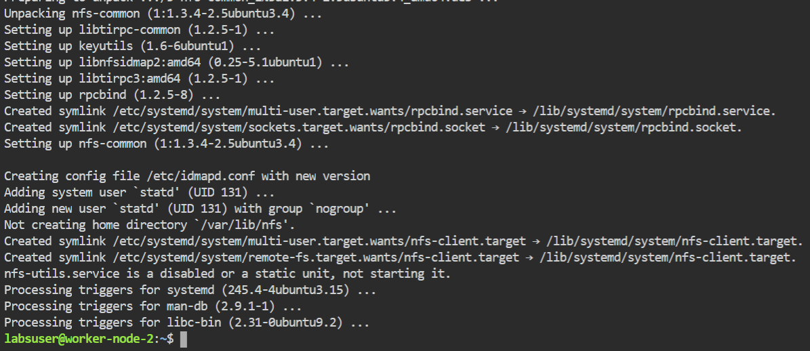



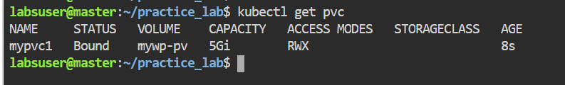

**Creating Deployment for MySQL**

